**PRACTICAL FILE**

**DATABASE MANAGEMENT SYSTEM**

**KULVINDER BIDHURI**

**24/SCA/BCA[AI&ML]/034**

**IB**

***Q1) Create a table called Employee with the following structure***

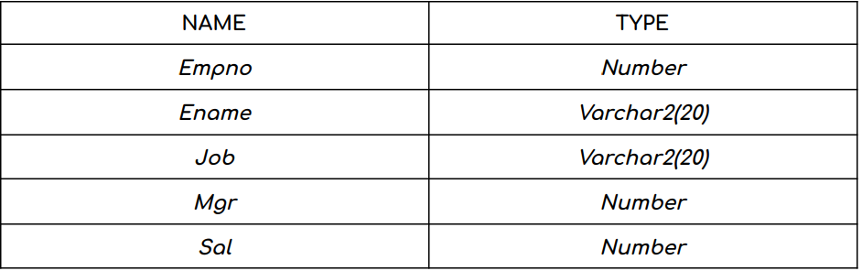

***1.*** *Add a column commission with domain to the employee table.*

***2.*** *Insert any five records into the table.*

***3.*** *Update the column details of job.*

***4.*** *Rename the column of Employ table using alter command.*

***5.*** *Delete the employee whose Empno is 19.*

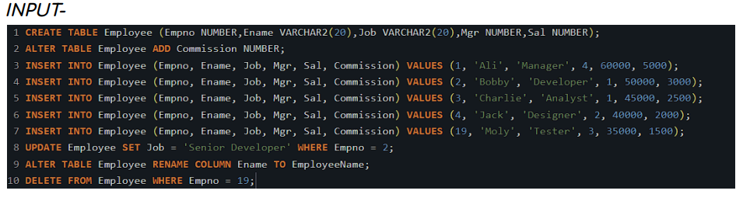

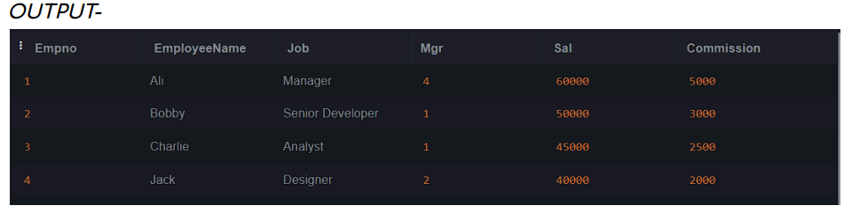

***Q2) Create department table with the following structure****.*

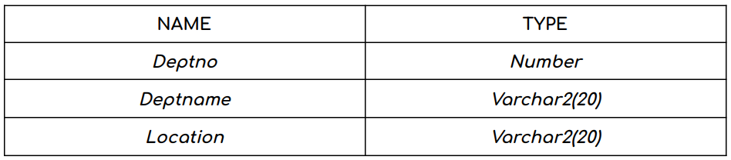

*1. Add column designation to the department table.*

*2. Insert values into the table.*

*3. List the records of emp table grouped by deptno.*

*4. Update the record where deptno is 9 .*

*5. Delete any column data from the table.*

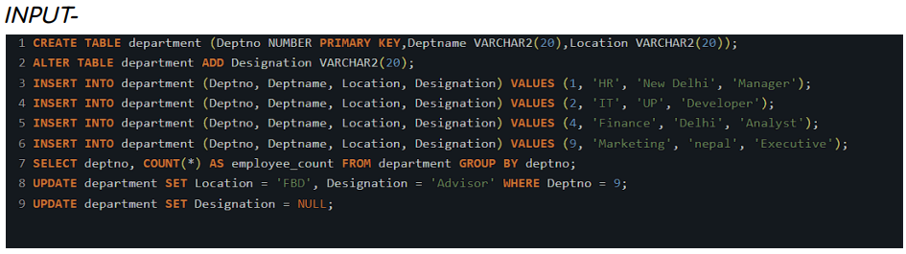

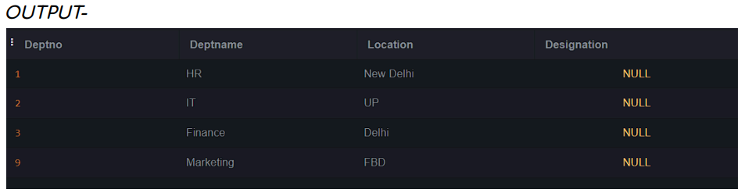

***Q3) Create a table called customer table.***

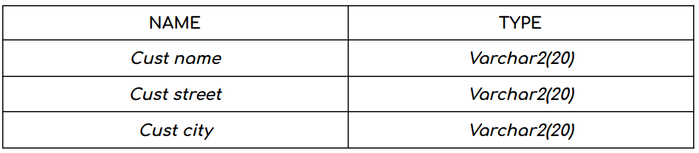

***1.*** *Insert records into the table.*

***2.*** *Add salary column to the table.*

***3.*** *Alter the table column domain.*

***4.*** *Drop salary column of the customer table.*

***5.*** *Delete the rows of customer table whose cust city is "hyd'.*

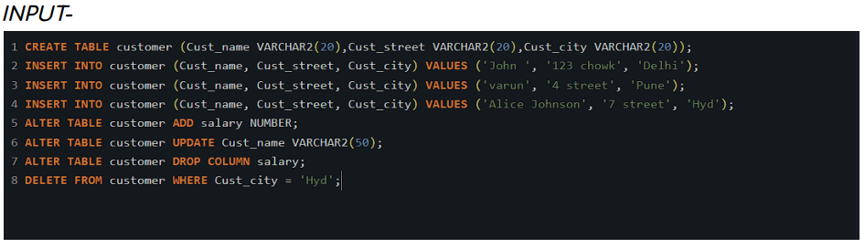

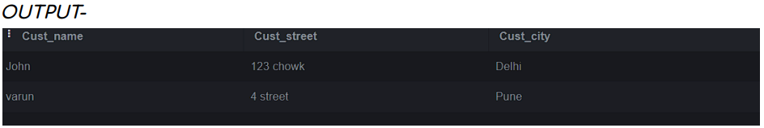

***Q4) Create a table called branch table.***

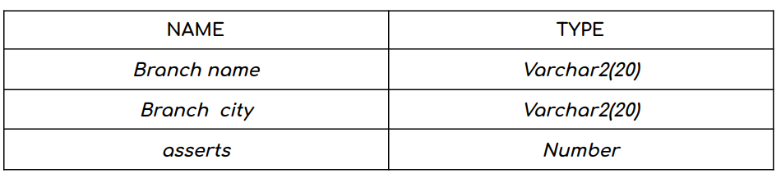

***1.*** *Increase the size of data type for asserts to the branch.* ***2.*** *Add and drop a column to the branch table.*

***3.*** *Insert values to the table.*

***4.*** *Update the branch name column.*

***5.*** *Delete any two columns from the table.*

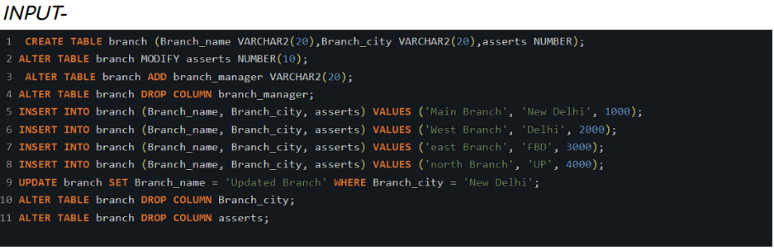

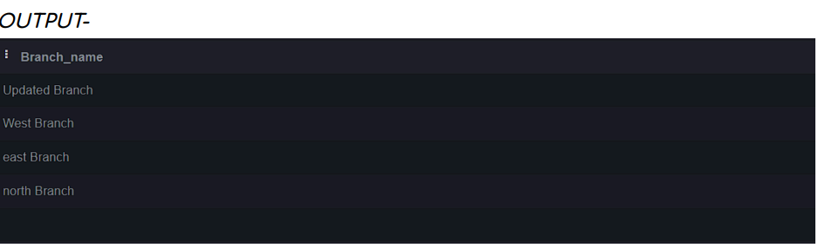

***Q5) Create a table called sailor table.***

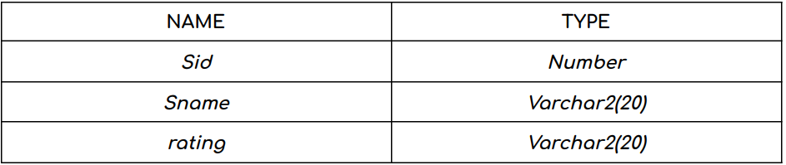

***1.*** *Add column age to the sailor table.*

***2.*** *Insert values into the sailor table.*

***3.*** *Delete the row with rating >8.*

***4.*** *Update the column details of sailor.*

***5.*** *Insert null values into the table.*

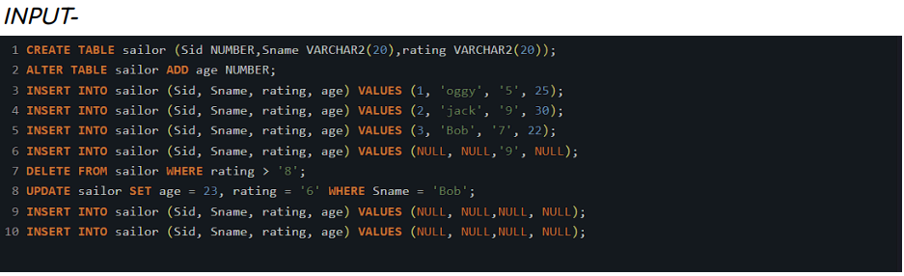

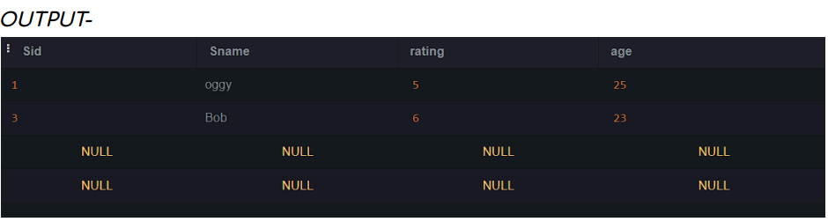

***Q6) Create a table called reserves table.***

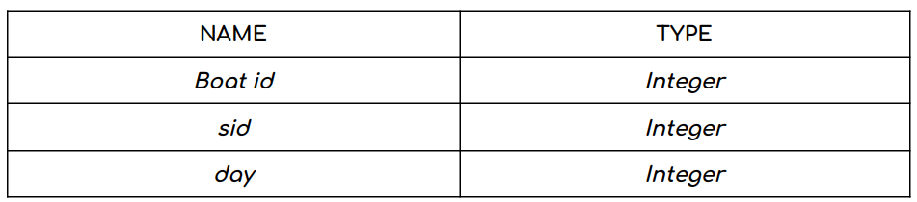

***1.*** *Insert values into the reserves table.*

***2.*** *Add column time to the reserves table.*

***3.*** *Alter the column day data type to date.*

***4****. Drop the column time in the table.*

***5.*** *Delete the row of the table with some condition.*

